**EDA Plots**

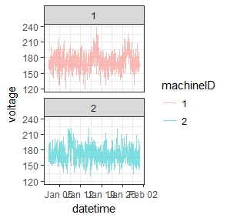

**Fig.1** Sample time plot on Volt for different machine ID

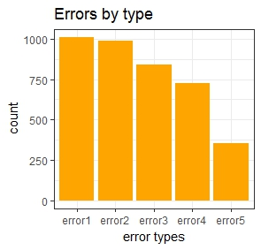

**Fig.2** Types of errors

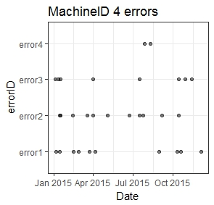

**Fig.3** Scatter plot of Machine ID w.r.t errors

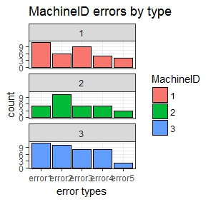

**Fig.4** Error by Machine ID

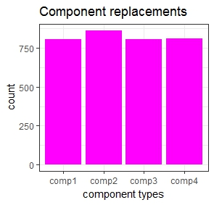

**Fig.5**. Count of Component Replacement

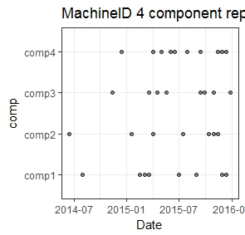

**Fig.6**. Comp. Replacement by Machine ID

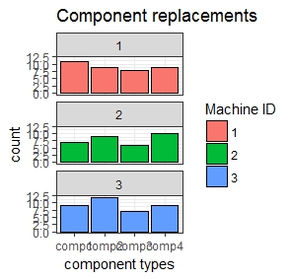

**Fig.7** Comp . Replacement by Machine ID Types

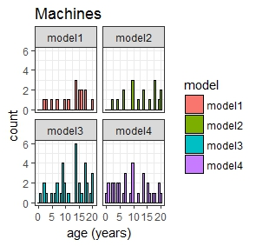

**Fig.8**. Machine age w.r.t. modes

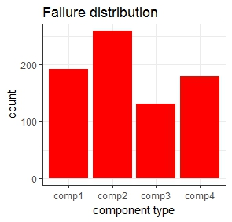

**Fig.9**. Failure Distribution across components

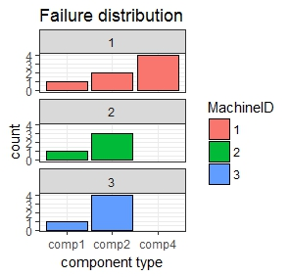

**Fig.10**. Failure distributions for different machines